**11.1 The Muscular System\***

Types of Muscle

1. Skeletal muscle
   1. Responsible for **voluntary movement** and therefore is innervated by **somatic nervous system**
   2. Sarcomeres = arrangement of actin and myosin into repeating units → appears striped or **striated**
   3. **Polynucleated** because it is formed as individual muscle cells fuse in long rods during development
   4. Two types of fibres
      1. **Red (slow twitch) fibres: oxidative phosphorylation (many mitochondria) + high myoglobin content (more iron, more red)**
         1. Also called dark meat in poultry
         2. Mainly for **support**
      2. **White (fast twitch) fibres: anaerobic metabolism**
         1. Active muscles like the pectoral muscle (breast meat)
         2. **Contract quickly** e.g. to run faster but fatigue easily
2. Smooth muscle
   1. Responsible for **involuntary action**, and therefore is controlled by the **autonomic nervous system**
   2. Present in the respiratory, reproductive, cardiovascular, and digestive system
   3. Appears **nonstriated** (fibres not well-organized even though the SM cells also contain actin and myosin)
   4. **Uninucleated**
   5. Can display **myogenic activity**, or contraction even **without neural input**
3. Cardiac muscle
   1. Comprises the contractile tissue of the heart
   2. Similarity to skeletal muscle
      1. Some cells may contain two nuclei
      2. Appears **striated**
   3. Similarities to smooth muscle
      1. **Primarily uninucleated**
      2. Muscle is **involuntary**, and innervated by the **autonomic nervous system**
   4. Can display **myogenic activity**
   5. Cells are connected with intercalated discs that contain **gap junctions** → direct flow of ions between cells → rapid and coordinated muscle cell depolarization → efficient contraction of cardiac muscle

Microscopic Structure of Skeletal Muscle

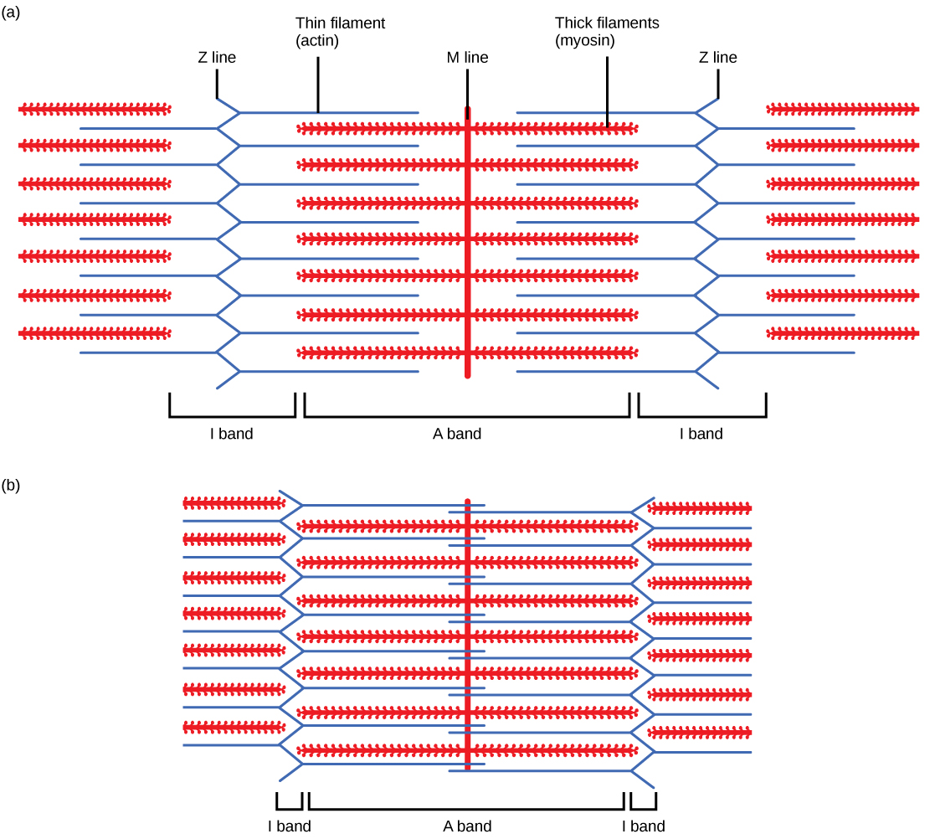

(Sarcomeres are the functional units of striated muscle)

* The sarcomere is the basic contractile unit of striated muscle
  + Sarcomeres are made of thick (myosin) and **t**hin (ac**t**in) filaments
  + **T**roponin and **t**ropomyosin are found on the **t**hin filament and regulate actin-myosin interactions
* The sarcomere can be divided into different lines, zones and bands
  + **Z-Z** is the end of the alphabet, and the end of the sarcomere
  + **M** - **M**iddle of the **m**yosin filaments
  + **I-I** is a thin letter (**thin** filaments only)
  + **H-H** is a **thick** letter (**thick** filaments only)
  + **A-A**ll of the thick filament, whether or not it is overlapping
* During contraction, the H-zone, I-band, the distance between Z lines, and the distance between M lines all become smaller, but the **A-band’s size remains constant**

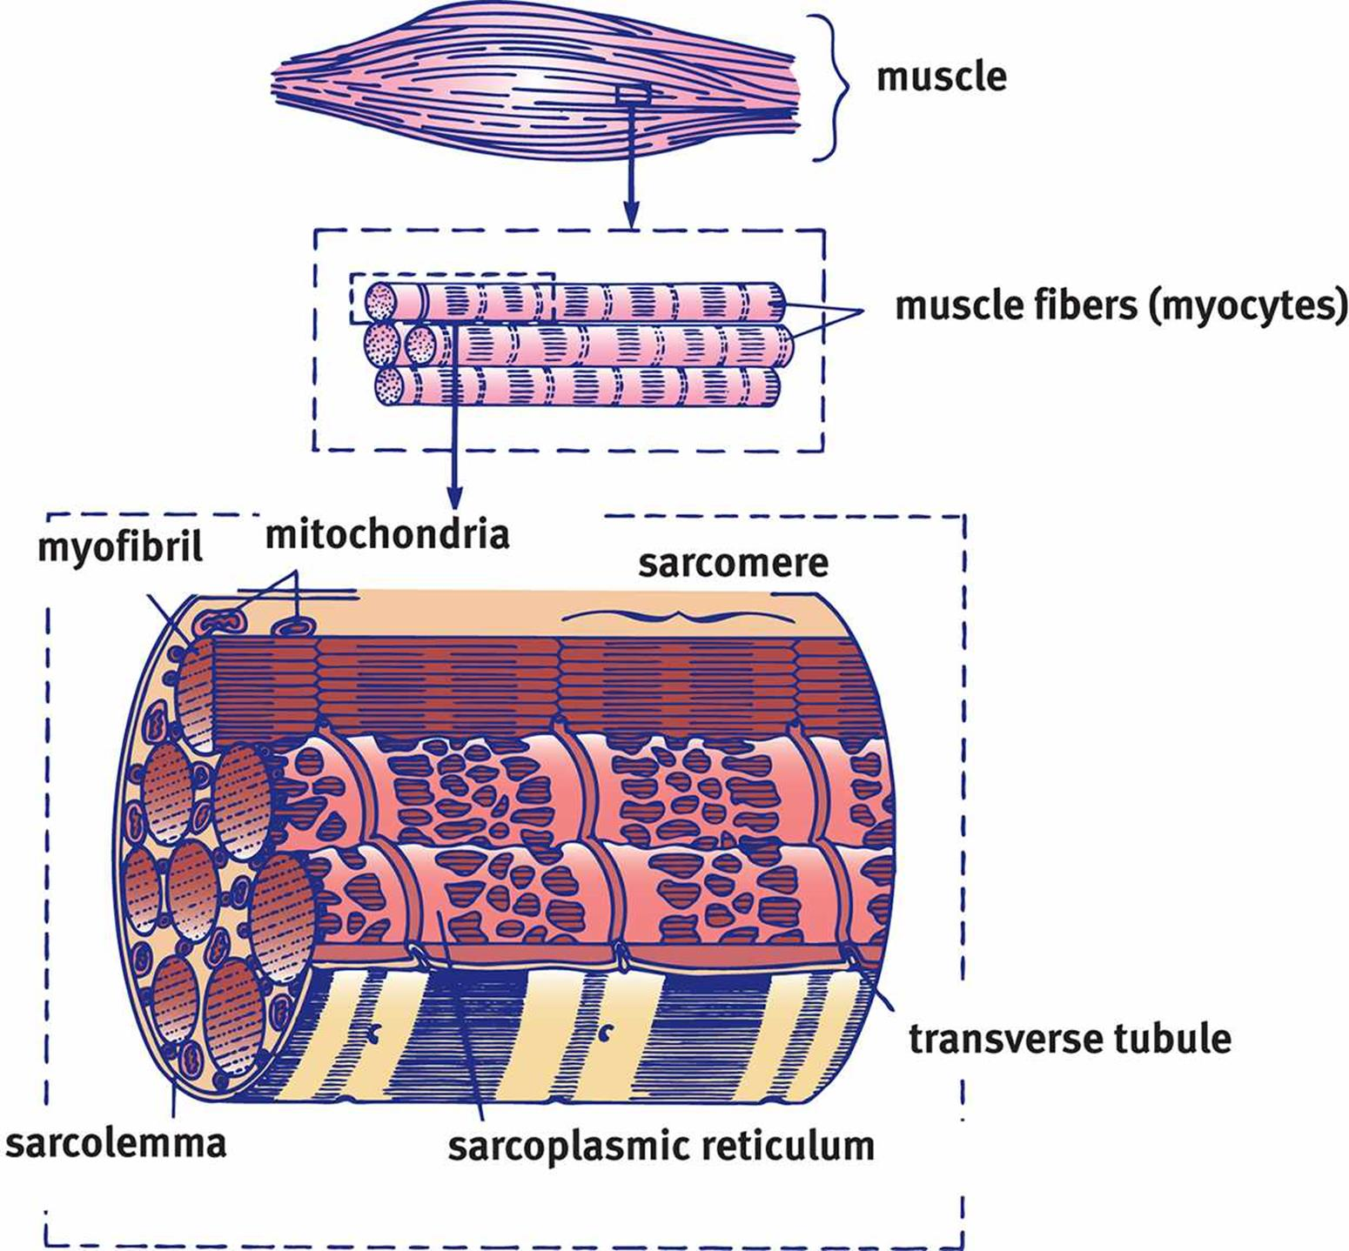

(Architecture of Skeletal Muscle)

* Sarcomeres attach end-end (in series) to become **myofibrils**, and each myocyte (muscle cell or muscle fiber) contains many myofibrils
  + Myofibrils are surrounded by **sarcoplasmic reticulum (SR)**, a calcium-containing modified endoplasmic reticulum
  + The cell membrane of a myocyte is called the **sarcolemma**
  + A system of **T-tubules** is connected to the sarcolemma and oriented perpendicularly to the myofibrils, allowing the signal to reach all parts of the muscle

Muscle Contraction

* Overall idea: Muscle contraction begins at the neuromuscular junction, where the neuron releases acetylcholine that binds to receptors on the sarcolemma, causing depolarization
* Sequence of events:
  + **Active transport of Ca2+ into SR**
  + Action potential down the motor neuron
  + Triggers influx of Ca2+ that result in the release of vesicles containing the acetylcholine neurotransmitter
  + The ligand acetylcholine binds to Na+ ion channels (orange gates on the membrane of muscle cell, including T-tubule) → influx of Na+ across the motor end plate
  + Some magic protein complex that interfaces between T-tubule and sarcoplasmic reticulum
  + Ca2+ ions in the SR released into the muscle cell

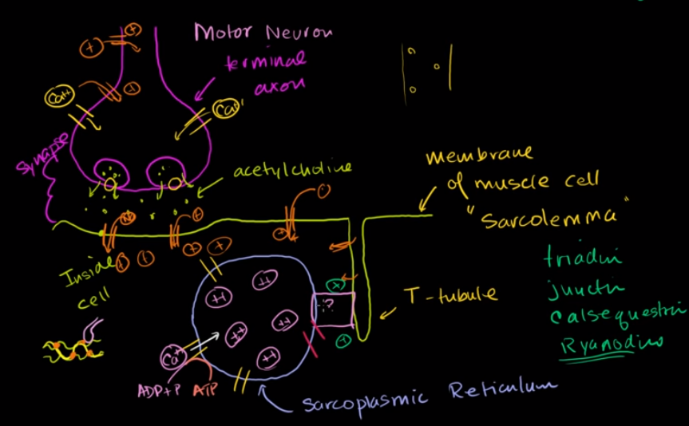

* + **Ca2+ binds to troponin → causes a shift in tropomyosin → exposes the myosin binding sites on the actin filament**
  + Myosin heads bind to the exposed sites on actin → form cross bridges → pull the actin filament along the thick filament → shortening of the sarcomere → contraction (sliding filament model)
    - The binding of ATP is required for releasing the myosin head from the actin filament
    - **It is the dissociation of ADP and Pi from myosin that is responsible for the power stroke, not the hydrolysis of ATP** (see step (c) below)
  + Muscle relaxes when acetylcholine is degraded by acetylcholinesterase, terminating the signal and allowing calcium to be brought back into the SR
  + **ATP binds to the myosin head, allowing to release from actin**

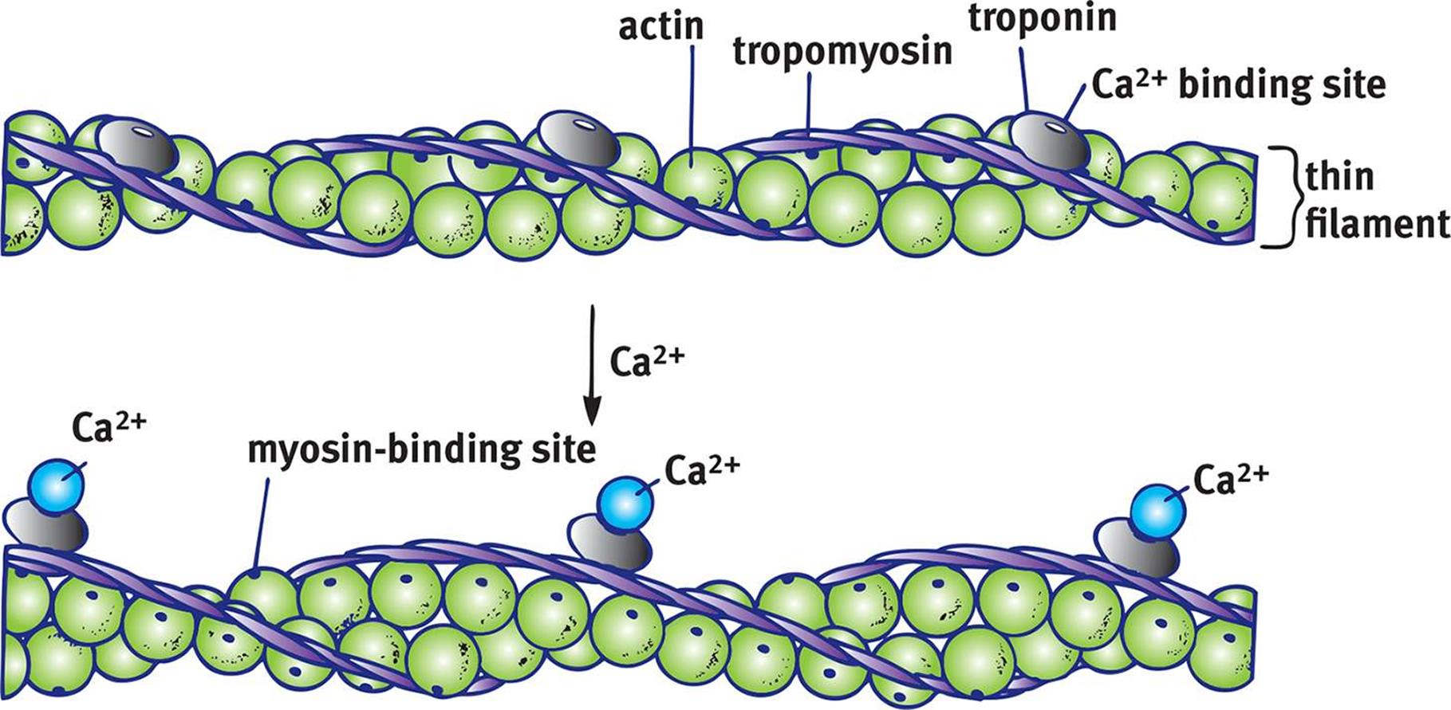

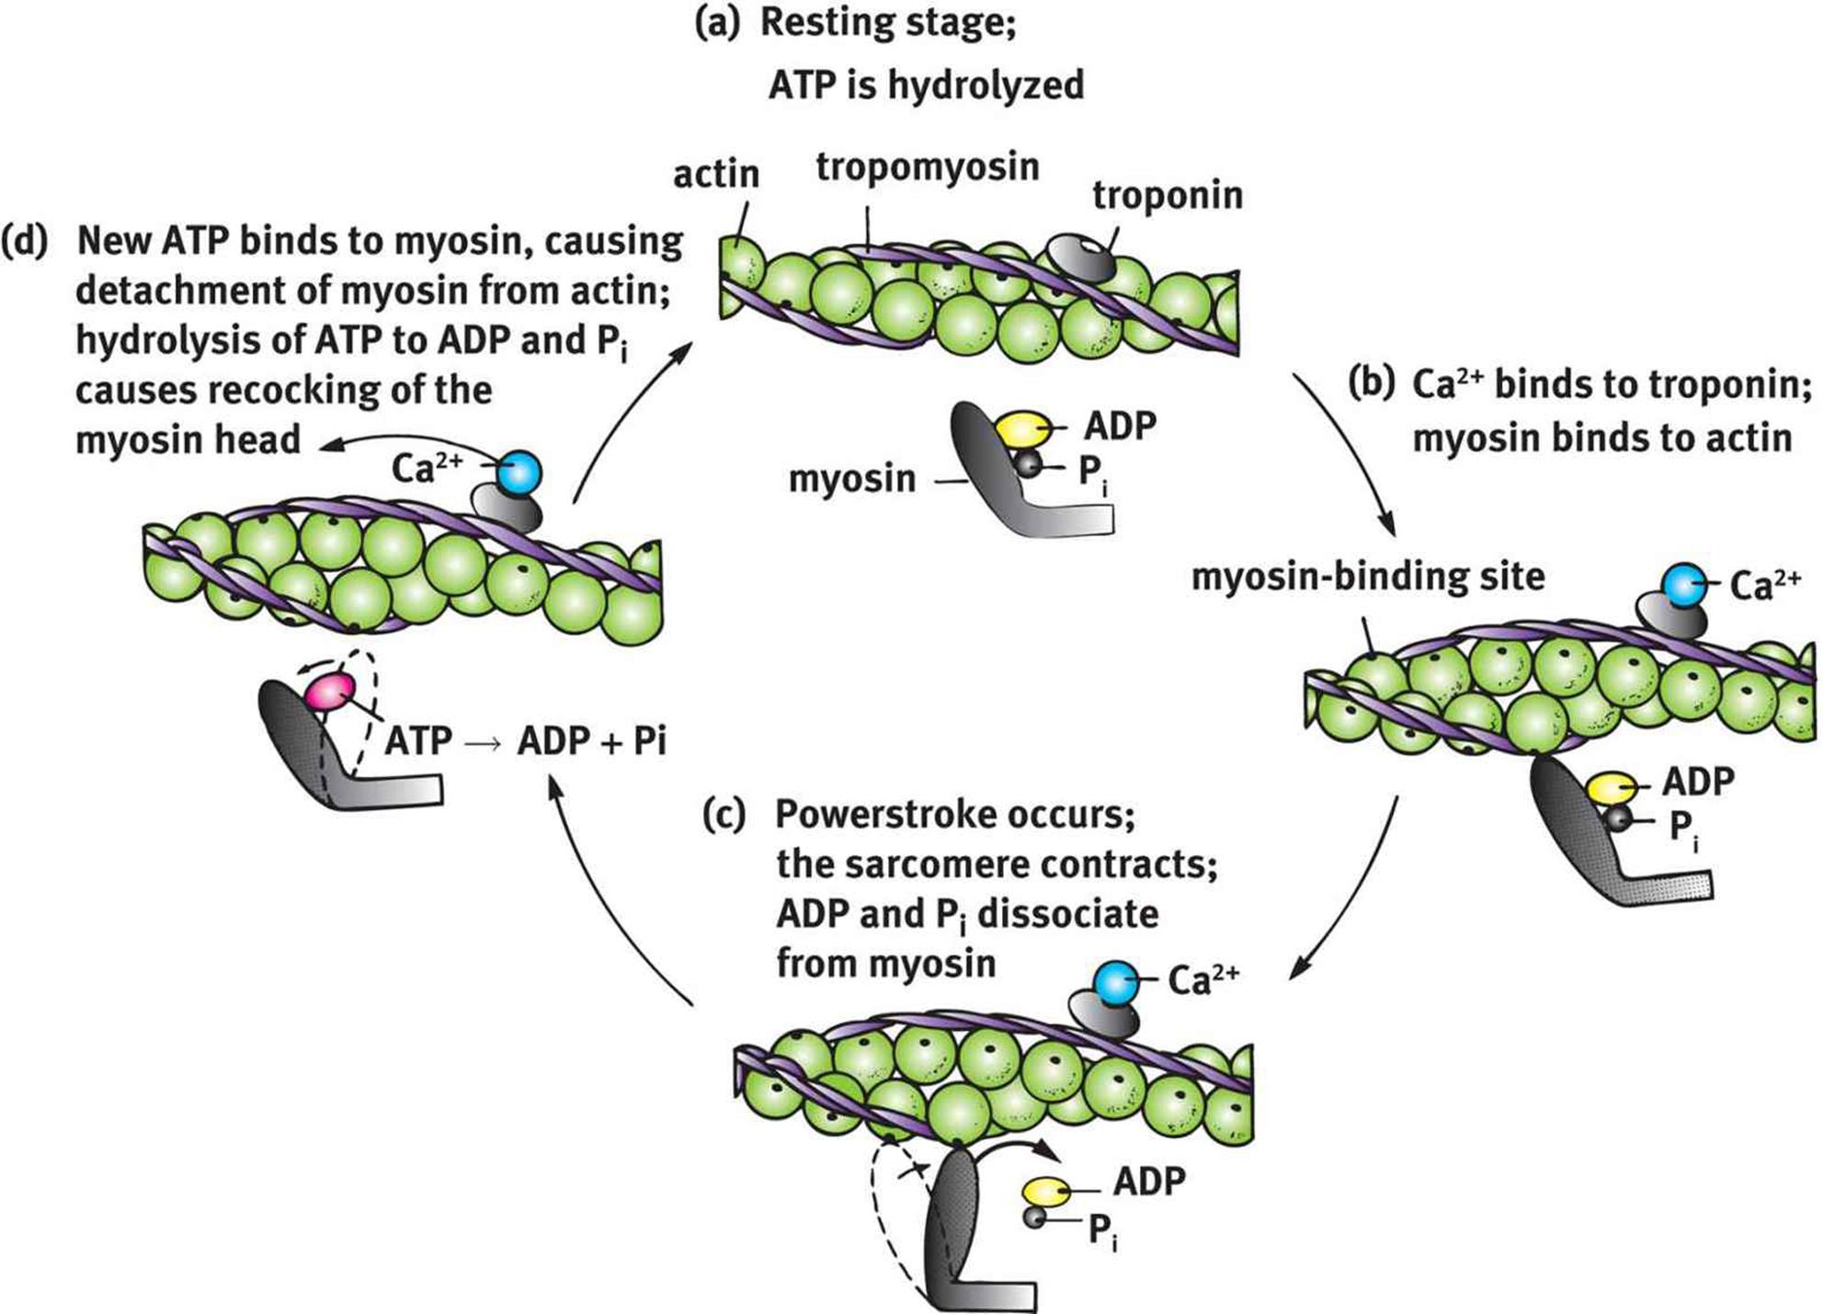

Simulation, Summation, and Muscle Fatigue

* Muscle cells exhibit an all-or-nothing response called a **simple twitch**
  + Addition of multiple simple twitches before the muscle has an opportunity to fully relax is called **frequency summation**
  + Simple twitches that occur so frequently as to not let the muscle relax at all can lead to **tetanus**, a more prolonged and stronger contraction
* Muscle cells have additional energy reserves to reduce **oxygen debt** (the difference between the amount of oxygen needed and the amount present) and forestall fatigue
  + **Creatine phosphate** can transfer a phosphate group to ADP, forming ATP
  + **Myoglobin** is a heme-containing protein that is a muscular oxygen reserve

**11.2 The Skeletal System**

* Exoskeleton
  + Found in arthropods
  + Must be shed and regrown to accommodate growth
* Endoskeleton
  + Found in humans
  + Internal, not able to protect the soft tissue structures as well as exoskeletons
  + Better able to accommodate the growth of a larger organism though

Skeletal Structure

1. Axial skeleton
   1. Consists of structure in the midline e.g. skull, vertebral column, ribcage, and hyoid bone
2. Appendicular skeleton
   1. Consists of the bones of the limbs, the pectoral girdle, and the pelvis

Bone Composition

* Bone is derived from embryonic mesoderm and includes both compact and spongy (cancellous) types
  + Compact bone provides strength and is dense
  + Spongy or cancellous bone has a lattice-like structure consisting of bony spicules known as **trabeculae**. The cavities are filled with bone marrow
  + Long bones contain shafts called **diaphyses** that flare to form **metaphyses** and that terminate in **epiphyses.**
    - The epiphysis contains an epiphyseal (growth) plate that causes linear growth of the bone
  + Bone is surrounded by a layer of connective tissue called **periosteum**
    - Some periosteum cells are capable of differentiating into bone-forming cells → necessary for bone growth and repair
  + **Tendons** attach muscle to bone
  + **Ligaments** attach bones together at joints
* Bone matrix has both organic components, like collagen, glycoproteins, and other peptides, and inorganic components, like **hydroxyapatite**
  + Bone is organized into concentric rings called **lamellae** around a central **Haversian** or **Volkmann’s canal**. This structural unit is called an osteon or **Harvesian system**
  + Between lamellar rings are **lacunae**, where osteocytes reside, which are connected with **canaliculi** to allow for nutrient and waste transfer

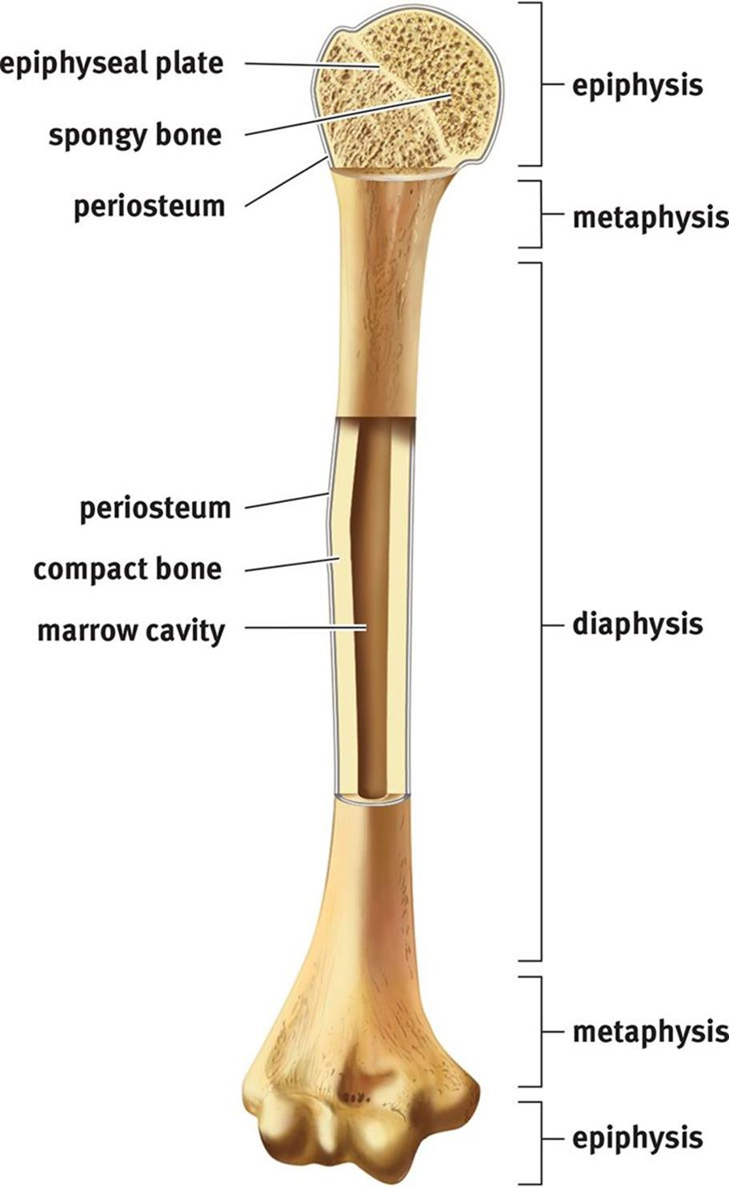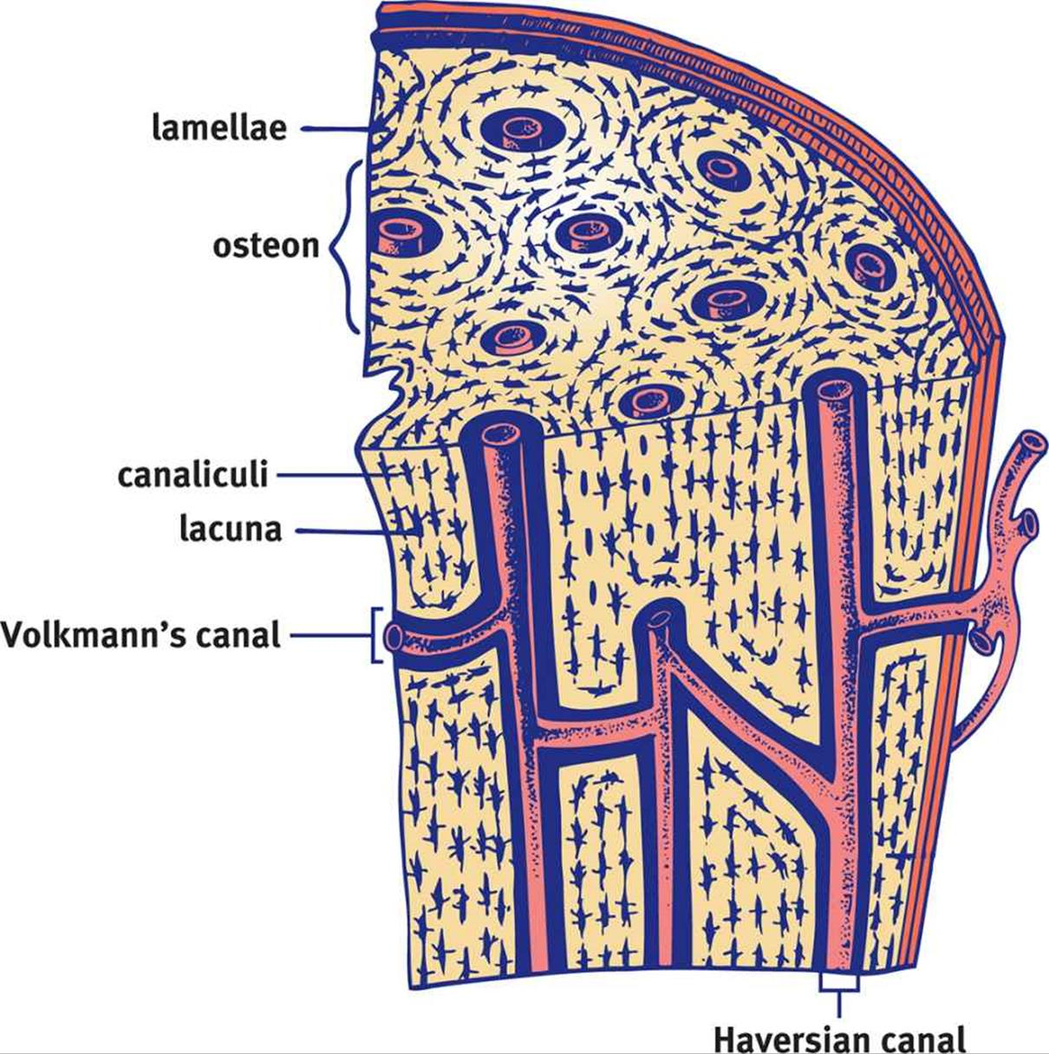

* **Bone remodelling** → Osteo**b**lasts **b**uild bone, osteo**c**lasts **c**hew (resorb) bone
  + Parathyroid hormone (PTH) increases bone resorption → increases calcium and phosphate concentrations in the blood
  + Vitamin D (activated by PTH) also increases bone resorption → BUT this effect encourages the growth of new, stronger bone → increases **bone strength**
  + Calci**ton**in **tones** down blood calcium levels by promoting bone formation

Cartilage

* Cartilage is a firm, elastic material secreted by **chondrocytes**. Its matrix is called **chondrin**
  + Cartilage is usually found in areas that require more flexibility or cushioning
    - E.g. external ear, nose, walls of the larynx and trachea, intervertebral discs, and joints
  + Cartilage is avascular (without blood or lymphatic vessels) and is not innervated
* In fetal life, cartilage hardens to form bone through **endochondral ossification**
* Some bones, especially those of the skull, form directly from undifferentiated tissue (mesenchyme) in **intramembranous ossification**

Joints and Movement

* Joints may be classified as **immovable** or **movable**
  + Immovable joints are fused together to form sutures or similar fibrous joints
  + Movable joints are usually strengthened by ligaments and contain a synovial capsule
  + Synovial fluid, secreted by the synovium, aids in motion by lubricating the joint
  + Each bone in the joint is coated with articular (means relating to a joint) cartilage to aid in movement and provide cushioning
* Antagonistic pairs of muscles serve opposite functions; when one muscle contracts, the other lengthens

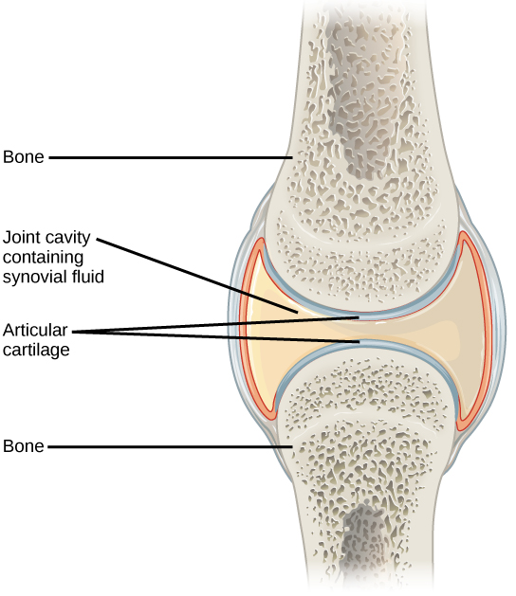

(Structures in a **movable joint**)